AI ASSISTED CODING
NAME: M.SAI RITHWIK REDDY BATCH:50 HL-NO: 2303A52497
Lab 6.3:
Lab 6: AI-Based Code Completion – Classes, Loops, and Conditionals
Lab Objectives
• To explore AI-powered auto-completion features for core Python constructs such as classes,loops, and conditional statements.
• To analyze how AI tools suggest logic for object-oriented programming and control structures.
• To evaluate the correctness, readability, and completeness of AI-generated Python code-Lab Outcomes (LOs):
Lab Outcomes (LOs) -
After completing this lab, students will be able to:
• Use AI tools to generate and complete Python class definitions and methods.
• Understand and assess AI-suggested loop constructs for iterative tasks.
• Generate and evaluate conditional statements using AI-driven prompts.
• Critically analyze AI-assisted code for correctness, clarity, and efficiency.

Task Description #1: Classes (Student Class)
Scenario
You are developing a simple student information management module.
Task
• Use an AI tool (GitHub Copilot / Cursor AI / Gemini) to complete a Student class.
• The class should include attributes such as name, roll number, and branch.
• Add a method display_details() to print student information.
• Execute the code and verify the output.
• Analyze the code generated by the AI tool for correctness and clarity.
Expected Output #1
• A Python class with a constructor (__init__) and a display_details() method.
• Sample object creation and output displayed on the console.
• Brief analysis of AI-generated code.

Prompt -
"Generate a Python class named Student with attributes for name, roll number, and branch, including a method display_details() to print the student's information, along with a constructor (init) for initialization.
Code:
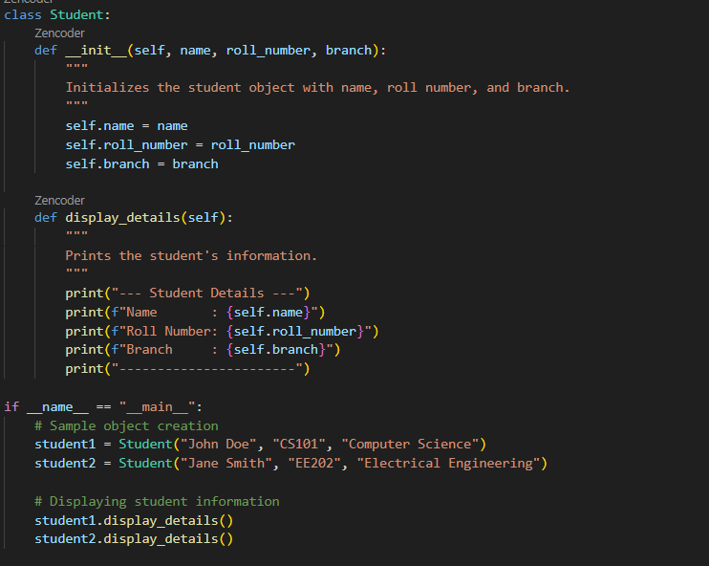
Output:
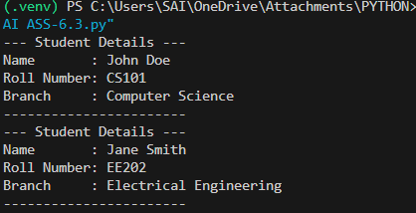

Task Description #2: Loops (Multiples of a Number)
Scenario
You are writing a utility function to display multiples of a given number.
Task
• Prompt the AI tool to generate a function that prints the first 10 multiples of a given number
using a loop.
• Analyze the generated loop logic.
• Ask the AI to generate the same functionality using another controlled looping structure (e.g.,
while instead of for).
Expected Output #2
• Correct loop-based Python implementation.
• Output showing the first 10 multiples of a number.
• Comparison and analysis of different looping approaches
Prompt:-"Generate a Python function that prints the first 10 multiples of a given number using a for loop, and then create the same functionality using a while loop. Analyze and compare the logic of both looping structures."
Code:
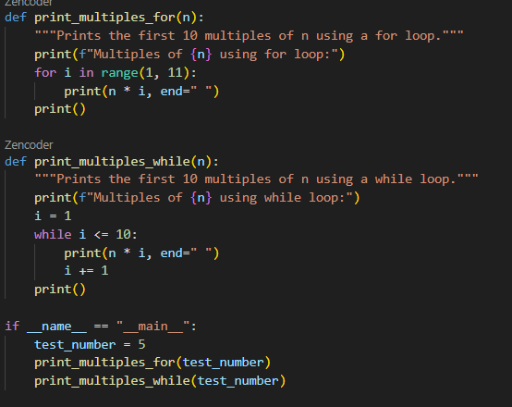
Output:
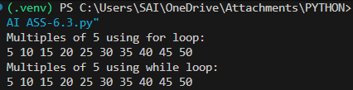
Task Description #3: Conditional Statements (Age Classification)
Scenario
You are building a basic classification system based on age.
Task
• Ask the AI tool to generate nested if-elif-else conditional statements to classify age groups
(e.g., child, teenager, adult, senior).
• Analyze the generated conditions and logic.
• Ask the AI to generate the same classification using alternative conditional structures (e.g.,
simplified conditions or dictionary-based logic).
Expected Output #3
• A Python function that classifies age into appropriate groups.
• Clear and correct conditional logic.
• Explanation of how the conditions work
Prompt:- "Generate a Python function that classifies age into groups (child, teenager, adult, senior) using nested if-elif-else statements, and then create an alternative classification using simplified conditions or dictionary-based logic. Analyze the logic of both approaches."
Code:
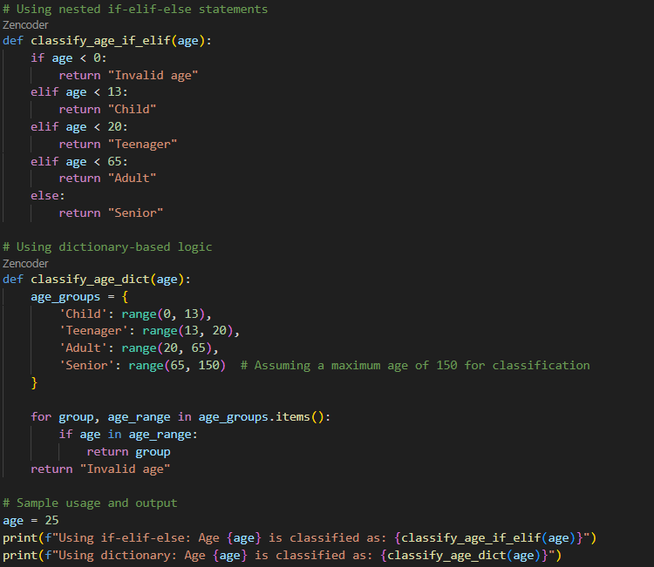
Output:
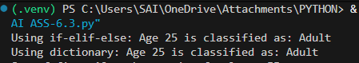
Task Description #4: For and While Loops (Sum of First n Numbers)
Scenario
You need to calculate the sum of the first n natural numbers.
Task
• Use AI assistance to generate a sum_to_n() function using a for loop.
• Analyze the generated code.
• Ask the AI to suggest an alternative implementation using a while loop or a mathematical formula.
Expected Output #4
• Python function to compute the sum of first n numbers.
• Correct output for sample inputs.
• Explanation and comparison of different approaches.
Prompt:- "Generate a Python function named sum_to_n() that calculates the sum of the first n natural numbers using a for loop. Additionally, create an alternative implementation using a while loop or a mathematical formula. Analyze and compare the logic and efficiency of both approaches."
Code:
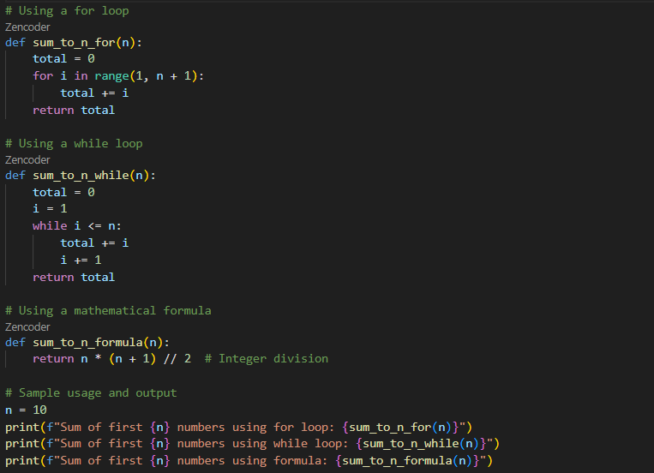
Output:
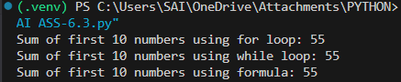
Task Description #5: Classes (Bank Account Class)
Scenario
You are designing a basic banking application.
Task
• Use AI tools to generate a Bank Account class with methods such as deposit(), withdraw(),
and check_balance().
• Analyze the AI-generated class structure and logic.
• Add meaningful comments and explain the working of the code.
Expected Output #5
• Complete Python Bank Account class.
• Demonstration of deposit and withdrawal operations with updated balance.
• Well-commented code with a clear explanation.
Prompt:- "Generate a Python class named BankAccount that includes methods for deposit(), withdraw(), and check_balance(). Ensure the class structure is clear and logical. Add meaningful comments to explain the functionality of each method and demonstrate deposit and withdrawal operations with updated balance outputs."
Code:
class BankAccount:
def __init__(self, account_holder, initial_balance=0):
# Initialize the bank account with the account holder's name and an initial balance
self.account_holder = account_holder
self.balance = initial_balance

def deposit(self, amount):
# Deposit a specified amount into the account.
if amount > 0:
self.balance += amount
print(f"Deposited: ${amount:.2f}. New balance: ${self.balance:.2f}")
else:
print("Deposit amount must be positive.")
def withdraw(self, amount):
# Withdraw a specified amount from the account if sufficient funds are available.
if amount > 0:
if amount <= self.balance:
self.balance -= amount
print(f"Withdrew: ${amount:.2f}. New balance: ${self.balance:.2f}")
else:
print("Insufficient funds for this withdrawal.")
else:
print("Withdrawal amount must be positive.")
def check_balance(self):
# Return the current balance of the account.
return f"Current balance: ${self.balance:.2f}"
# Sample usage and demonstration
if __name__ == "__main__":
# Create a new bank account for John Doe with an initial balance of $100
account = BankAccount("John Doe", 100)
# Check the initial balance
print(account.check_balance())
# Deposit money
account.deposit(50)
# Withdraw money
account.withdraw(30)
# Attempt to withdraw more than the balance
account.withdraw(150)
# Check the final balance
print(account.check_balance())

Output:
